**CHAPTER 5**

**APPLICATION DEVELOPMENT**

The process of gathering business requirements, creating, prototyping, developing, testing, and continuously improving and debugging software is known as application development.

Modern application development embraces agility, reliability, and security. Using highly customized technologies that focus on human centred design, project provides application that focus on your serving people.

The project application focuses on mainly the below mentioned mechanisms

* Eye Mechanism
* Motion Mechanism.
* Hand Mechanism

Giving the project the tools it needs to produce high-quality goods on time, adapt quickly to changing consumer needs (like switching between the line following to motion to eye movement). Agility, dependability, and security are all embraced in this project.

**5.1 Overview of the mobile application**

The app uses application software as the main building block as application software enables to develop for specific uses alone.

Application software is helps end users execute specified tasks. It is a product or program designed specifically to fulfil the needs of end consumers .it includes eye motion, arm motion and robocar motion combined or individually.

Python programming language is easy as it does not follow particular syntax and has multiple libraries that support complex functions like face recognition, voice detection like open cv modules.

The project uses such technical coding for the robot to function and thus make it versatile. The most convenient language was python programming language as it does not take lot of time to learn and code things appropriately and efficiently and also debugging in python becomes easy compared to any other programming languages.

**5.2 Mobile Application Development**

The process of creating software for smartphones, tablets, and digital assistants—most often for the Android and iOS operating systems—is known as mobile application development.   
 The software can be accessed via a mobile web browser, downloaded from a mobile app store, or preinstalled on the device. The programming and markup languages used for this kind of software development include Java, Swift, C# and HTML5.

Mobile app development is quickly developing. Organizations in a variety of sectors, including government, insurance, healthcare, and retail, telecommunications, and e-commerce, need to satisfy consumer expectations for quick, easy ways to conduct business and obtain information.

Thus, the project uses the mobile application for its most of the movements that would provide services to the common people at affordable cost.

The most widely used method for individuals and companies to access the internet these days is through mobile devices and the applications that maximize their potential. Project aims to create the mobile applications that their partners, consumers, and staff want if wanted it to remain successful, relevant, and responsive.

There are two ways to code for an application one is by using programming languages and two by using block codes. The project uses block coding as its backbone for application development.

The block coding has an advantage of easiness in programming for non-programmers as well as for beginners thus app development was easy and fast.

**5.3 MIT App Inventor**

A high-level block-based visual programming language called MIT App Inventor (also known as MIT AI2) was created by Google at first and is currently maintained by the Massachusetts Institute of Technology. It enables novices to develop computer programs for the two operating systems iOS and Android which are currently in beta testing as of September 25, 2023. It is open-source and free [51].

Like Scratch, its primary audience consists students learning computer programming.

Project uses design applications that can be tested on Android devices and compiled to operate as Android apps using the web interface, which has a graphical user interface (GUI) that is very similar to Scratch and Star Logo. It makes use of the MIT AI2 Companion smartphone app, which offers live testing and debugging.

App Inventor offers connectivity with a variety of web services, including Firebase and Google Sheets.

Google drew on extensive earlier research in educational computing as well as internal work on online development environments while developing App Inventor.

Project has a combined application for eye movement, motion control and hand movement where there is incorporation of multiple layouts that would take the user control to the respective handling page for respective movements.

There are basically three layouts:

1. Motion control
2. Eye movement
3. Arm movement

**5.3.1 Motion Control:**

The motion control of the robot can be achieved via the app created in MIT app Inventor

* The over view of the page visible for the end users to control the lower body motion of the robot.
* Project has a Bluetooth connected to the mobile and operated and controlled by the mobile application and thus provides the proper control via buttons and tabs as shown in the Fig 5.1 below
* The layout saying **“AVAILABLE DEVICES”** will have shown devices and the buttons that are to be depressed for the motion of the robot (left, right , forward and backward)
* Show devices depressed will show the available devices with the Bluetooth on and then connect to the device and then start using the layouts for movements.
* The robot operates forward with F button depressed and moves left and right for L and R depressed respectively.
* S button would stop the robot under emergency or if the end users would really like to stop robot operation.

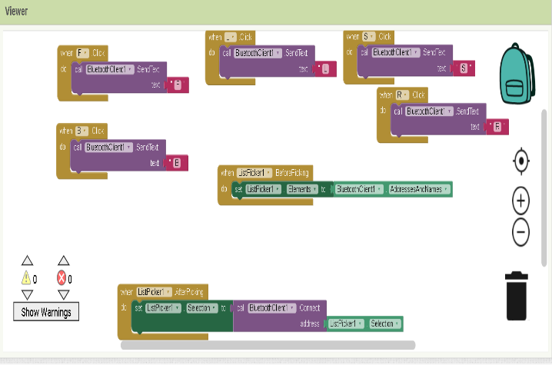 Fig 5.1 Describes the block coding part of the motion control application

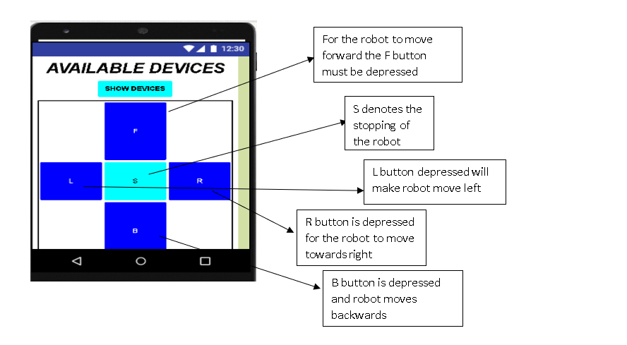

Fig 5.2 Shows the application layout for the motion control

**5.3.2 Eye Movement -**

The eye movement is provided with a slider-based selection of the direction of rotation of the eye in both x direction and y direction respectively.

* The thumb position of the slider is set 90 degree and then made to have movement in X – Y within the window of 60 degree to 120 degree.
* 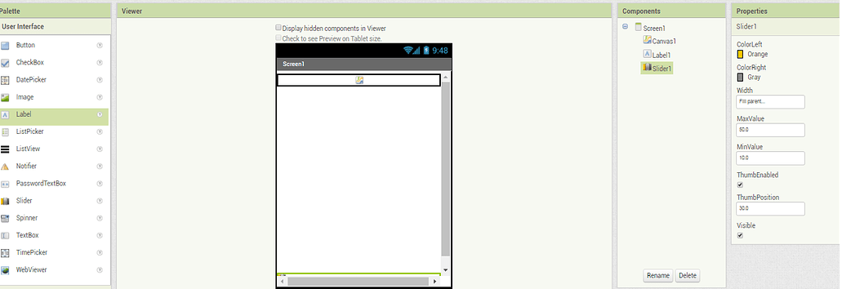The slider adjustments can be done to set the direction of the eye either towards “X” or “Y” direction

Fig 5.3 Shows the layout preparation in MIT App Inventor

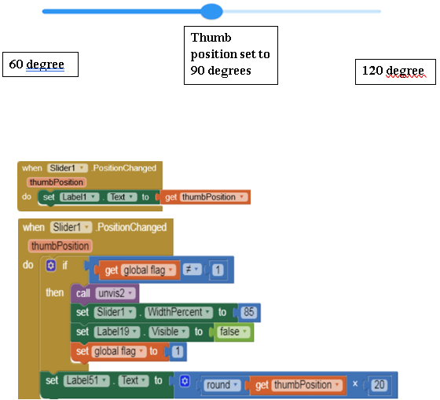

Fig 5.4 Shows the block coding of the eye movement application

**5.3.3 Arm movement**

The arm movement is provided with a slider-based selection of the direction of rotation of the arm in each joint.

* The robot can make five handily movements that are facilitated by mobile application that has been developed.
* The robot Is equipped with 5 motors having to with do 5 joints movement.
* The robot gripper, wrist pitch, wrist roll, and elbow, waist, shoulder etc are given different sliders with the help of which the end user can make the robot arm move in 5 individuals movements as shown in the Fig 5.5 below.
* The thumb position of the slider is set to 90 degrees and from there is a joy stick provided which it helps the forward and backward movement of the arm.
* The robot can work with the help of “taught” instructions where the application works as a teach pendant.
* Then when instruction is given, they can be saved and made to run for repetitive jobs if necessary.

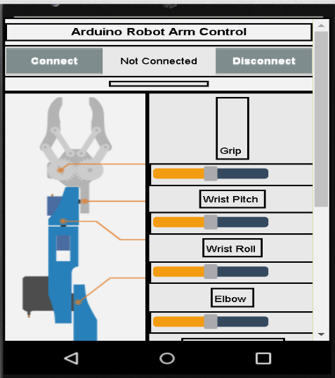

Fig 5.5 Describes the arm servo motion and movement

The block code to control the 5 individual Servo motors is shown in the Fig 5.6 below. Each function is a set instruction for the microcontroller to follow to control the arm with ease. The save and run feature allows the microcontroller to store the current co-ordinates of each servo for repetitive work allowing feasibility.

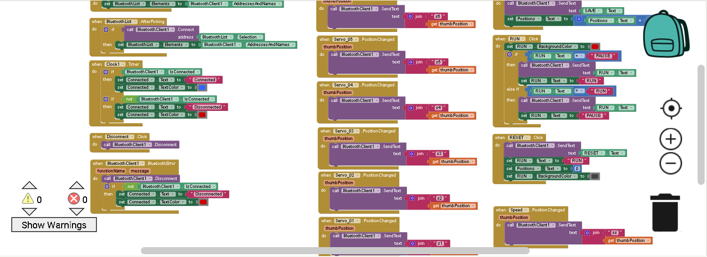

Fig 5.6 Describes the block coding for the arm motion in MIT app Inventor